**What is the Kingdom of God?**

**Reading:** Luke 4:16-21

Jesus travelled to Nazareth, the town where he grew up. On the Sabbath day he went to the synagogue as he always did. He stood up to read. The book of Isaiah the prophet was given to him. He opened the book and found the place where this is written:

The Spirit of the Lord is on me.

He has chosen me to tell the good news to the poor.

He sent me to tell prisoners that they are free

And to tell the blind that they can see again.

He sent me to free those who have been treated badly

And to announce that the time has come for the Lord to show his kindness.

Jesus closed the book, gave it back to the helper and sat down. As everyone in the synagogue watched him closely, he began to speak to them. He said, “While you heard me reading these words just now, they were coming true!”

**Thought about the reading**

A kingdom is a place where a king is in charge. We live in the kingdom of Great Britain and our king is King Charles. The people in a kingdom respect the king and try to keep his laws.

Jesus came to earth to set up the kingdom of God. In the reading, Jesus read from the book of Isaiah. Isaiah was a prophet who lived a long time ago and who spoke God’s message to the people. The verses Jesus read are about God’s kingdom.

Jesus is the king of God’s kingdom. This kingdom is not a place, like great Britain. It is wherever people do what God wants them to do, where people love each other and are kind to one another. In the reading Jesus says that in his kingdom, the poor hear good news, there is freedom, healing and kindness. If we follow Jesus, we are part of his kingdom.

**Prayer**

Lord Jesus, thank you that you are the king, and I am part of your kingdom. Help me to follow you as my king, and to do the things that you want me to do.

Lord Jesus, may your kingdom come.

Amen

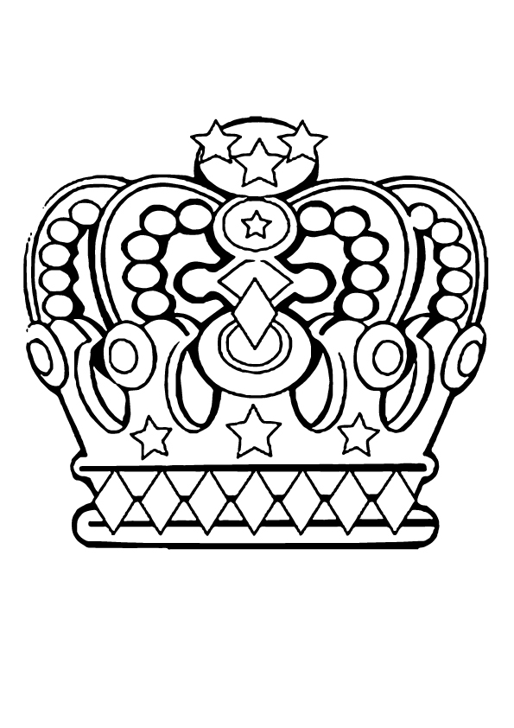**Jesus is King!**

**Cambridge Causeway**

Spring 2023

Bible Study notes

**The Kingdom of God**

1. **What is the kingdom of God?**

By Chrissy Cole